Cart Badge with Computed Signals
In this exercise, you will
- Create a cartItem interface to capture the quantity for each product
- Learn different techniques to inject the service (Dependency Injection)
- Use the Cart Badge

- Continue from previous store application. Make sure that the Terminal Server is there. Run the web project.
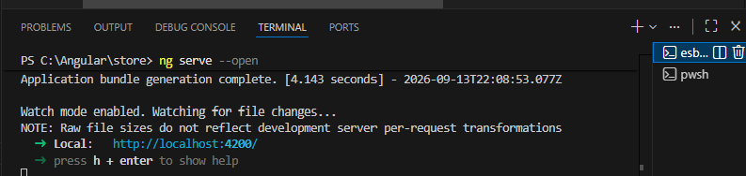
- To create a new cart service, run the command ng g i cart/cartItem in terminal, and change the interface code as below:
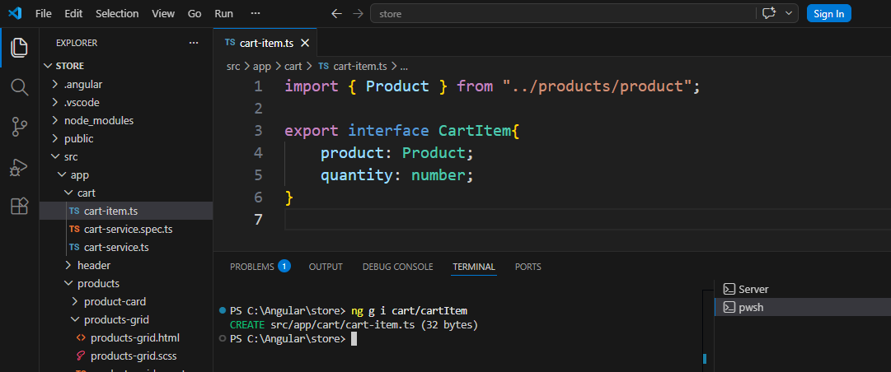
- Back to cart-service.ts, change the code as below:
import { Injectable, signal, computed } from '@angular/core';
import { Product } from '../products/product'
import { CartItem } from './cart-item';
@Injectable({
providedIn: 'root',
})
export class CartService {
private readonly cartItems = signal<CartItem[]>([]);
readonly totalItems = computed(
()=>this.cartItems().reduce((total,item)=>total + item.quantity, 0));

addToCart(product: Product):void{
//console.log('Added ', product.name)
this.cartItems.update((items)=>{
const existingItem = items.find((item)=>item.product.id==product.id);
if(existingItem){
return items.map((item)=>
item.product.id==product.id?{...item, quantity: item.quantity+1}:item);
}
return [...items, {product:product, quantity:1}]
});
}
}

- In the header.ts, add the following code
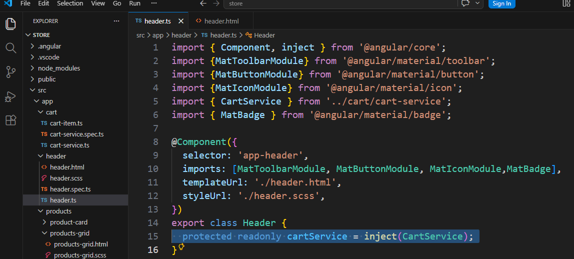
- In the header.html, change the following code
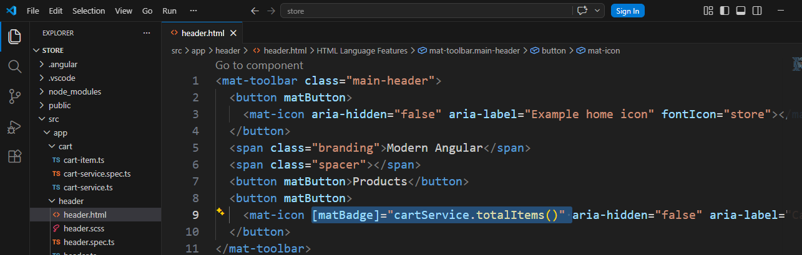
- Save all files. Now the browser will display the matbadge for cart as 0
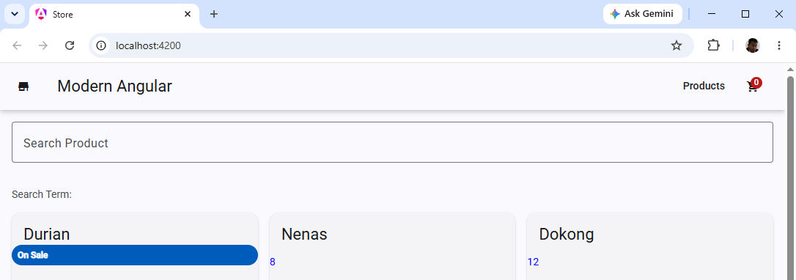
- Try Add Durian and Nenas
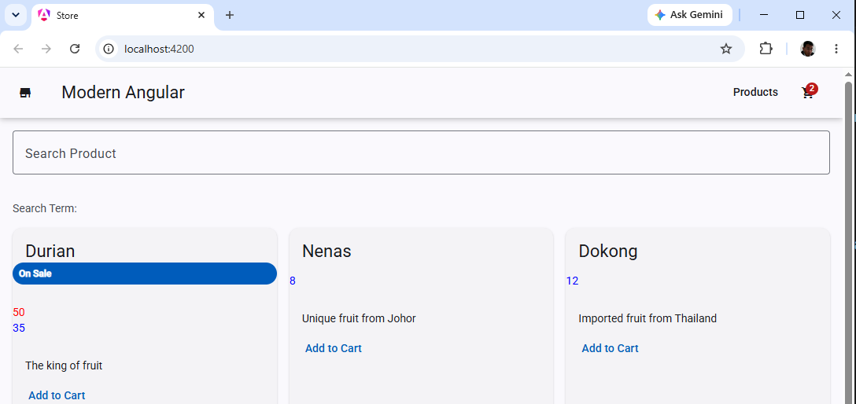
- Close VS Code

- Backup/Zip the application as store(Ex17).7z

